PAINFREE EU Erasmus+ sport project
2. LOCAL TRAINING
02.-04.04.2025.

The second training of the PAINFREE project participants took place on 2 and 4 April at the Faculty of Health Studies in Rijeka, which is a project of the Erasmus+ Sport programme co-financed by the European Union. FZSRI, as one of the project partners, organised the second part of the activities with the project participants. In addition to the faculty students leading group training sessions, the participants themselves filled out a questionnaire and survey designed by the partners. The questionnaire consisted of a series of questions that provided optimal insight into the current health status of each participant, with a focus on back and neck pain, and was based on the same questions as the questionnaire that the participants filled out at the first training. Since it is planned that between the 2 training sessions (activities) at the FZS, the participants will actively train and apply what they have learned from the educational programme of the first activity project, the questionnaire itself will therefore serve as an objective analysis of the effectiveness of the education and demonstration of exercises by the students by comparing the data from both questionnaires. The second questionnaire is an evaluation questionnaire on which the participants assessed the quality and satisfaction with the project and gave critical opinions on its implementation. In addition, all participants were given promotional materials from the PAINFREE project.
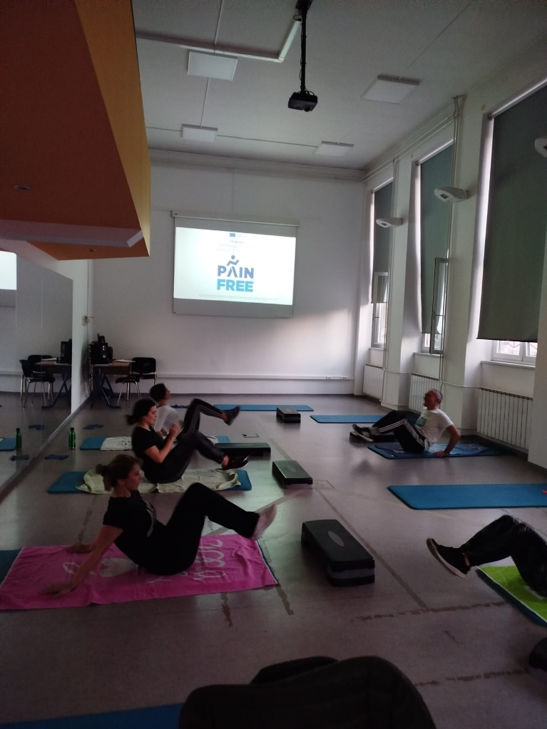
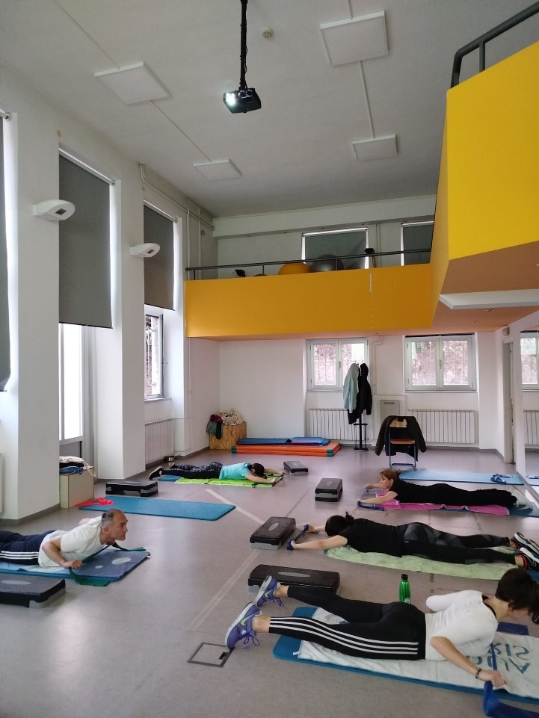
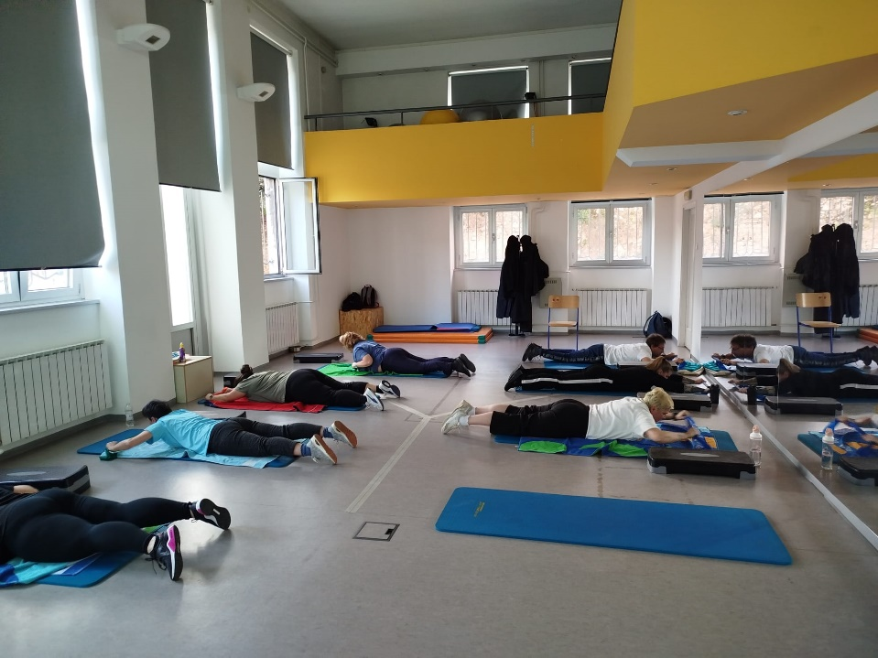
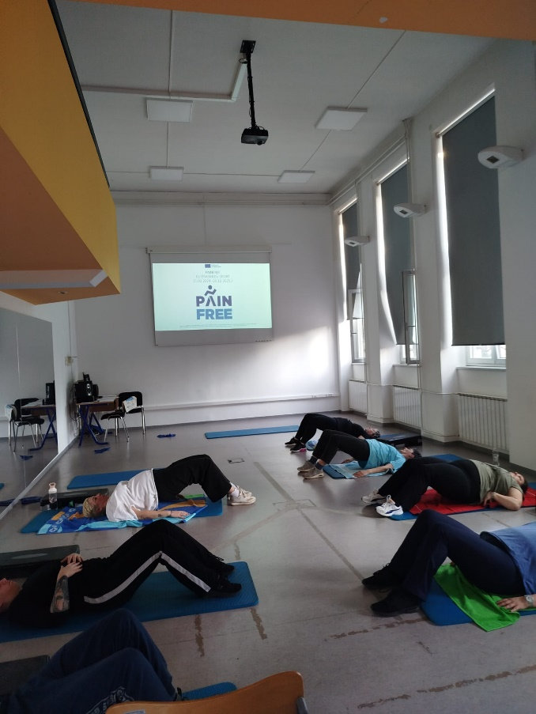
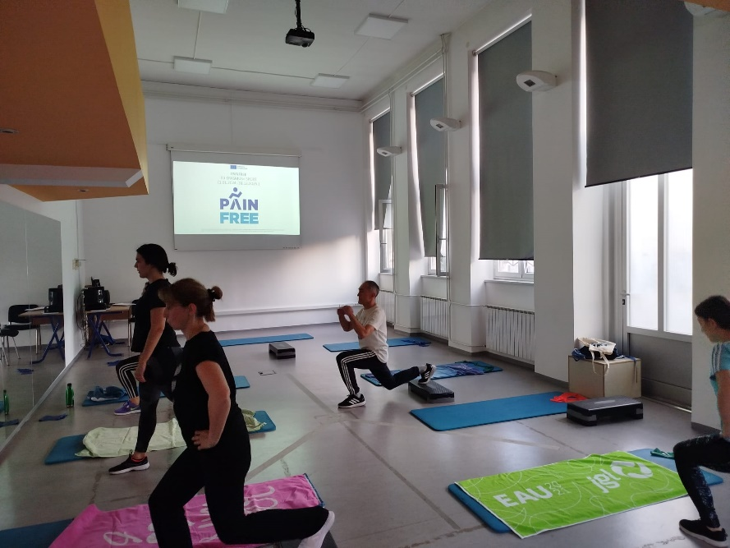
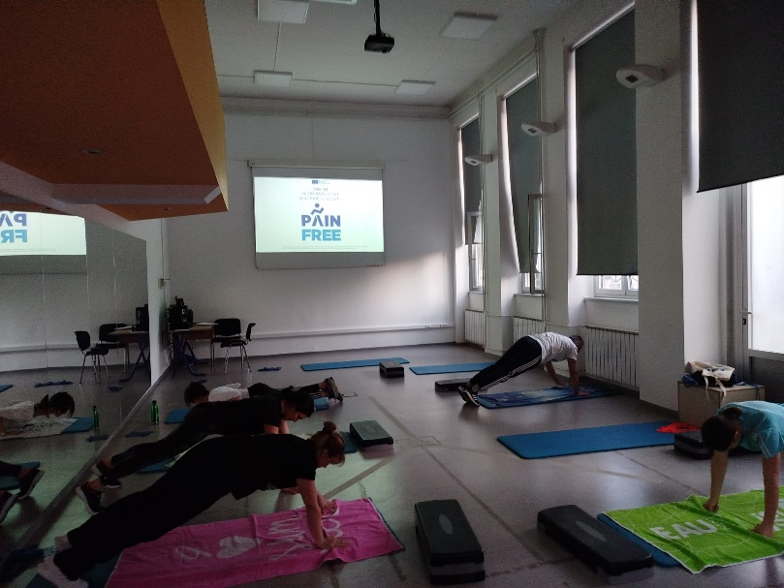
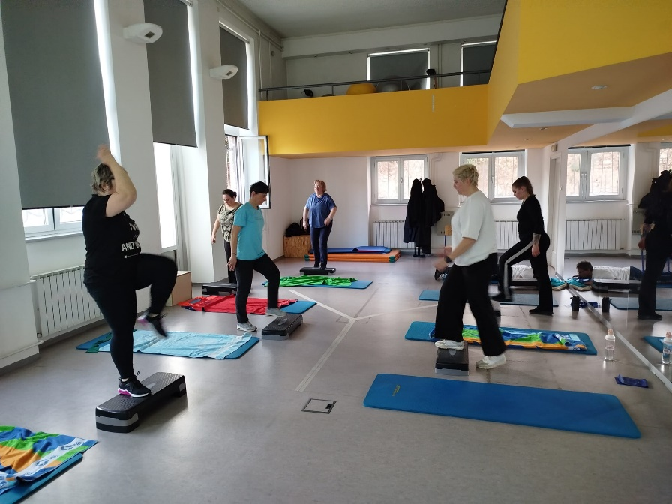
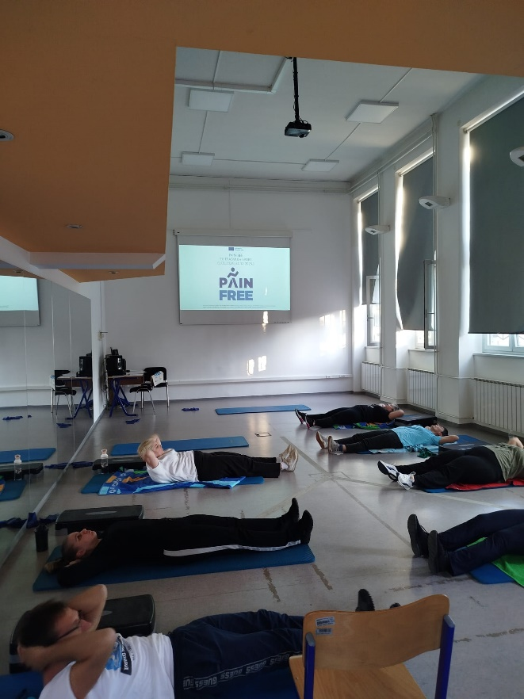
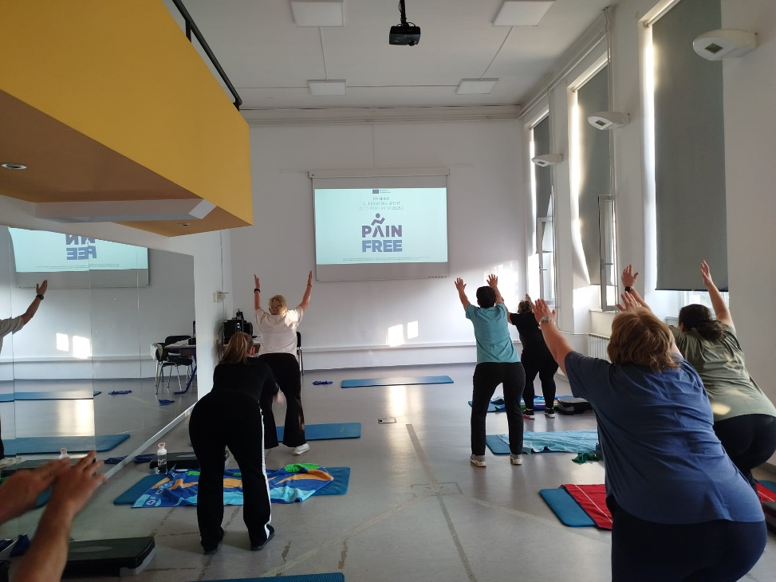
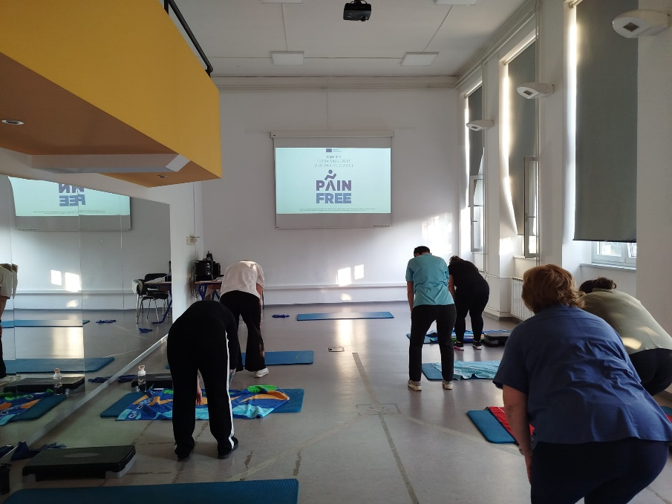
4.4.2025.
